Q.1)
Atmosphere (A)

K2
K1
Ocean Layer (O1)

K1
K1
Ocean Layer (O2)

K1
K1

Ocean Layer (O3)

K1
K1

Ocean Layer (O4)

K1
K1
Ocean Layer (O5)
Deep Ocean (O6)

K1
K1

Here are the ODEs for the carbon transfer thru the various layers:
$$\begin{aligned}\frac{dA}{dt}&=-k_{2}A+k_{1}O_{1} \\ \frac{dO_{1}}{dt}&=k_{2}A-2k_{1}O_{1}+k_{1}O_{2} \\ \frac{dO_{2}}{dt}&=k_{1}O_{1}-2k_{1}O_{2}+k_{1}O_{3} \\ \frac{dO_{3}}{dt}&=k_{1}O_{2}-2k_{1}O_{3}+k_{1}O_{4} \\ \frac{dO_{4}}{dt}&=k_{1}O_{3}-2k_{1}O_{4}+k_{1}O_{5} \\ \frac{dO_{5}}{dt}&=k_{1}O_{4}-2k_{1}O_{5}+k_{1}O_{6} \\ \frac{dO_{6}}{dt}&=k_{1}O_{5}-k_{1}O_{6}\end{aligned}$$

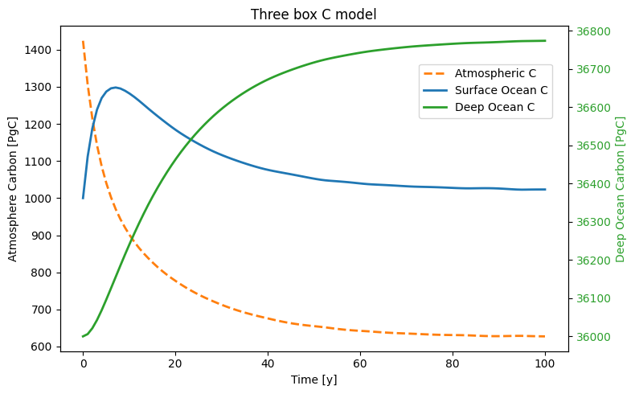
Here is a comparison between a simple 3-box model and a 7-box C model:

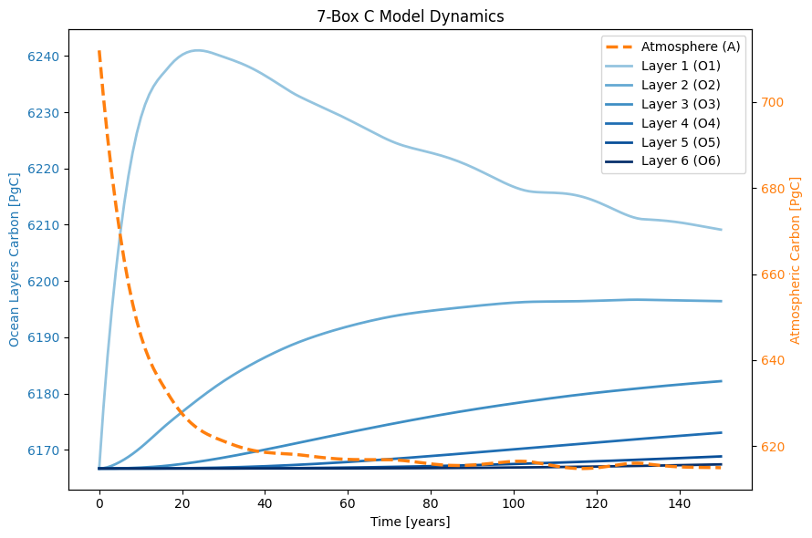
Here is the report on C change thru different layers over 150 years. It shows how C is gradually transferring from the atmosphere into the ocean layers. As it is showing the total system C net is zero and roughly the total 97 PgC from the atmosphere is stored in all ocean layers, but surprisingly not in the deepest ocean layer (!). So, almost 90% of the C is stored in the top 3 layers and about 10% of the total C will be stored in the next 3 deeper ocean layers. Since we considered a constant value for added C in the atmosphere, there will be a threshold at which all that C will finally be absorbed by the ocean, which is not a realistic assumption. So, this approach will be followed by adding a dynamically increasing C into the atmosphere to make the C modeling more physically sensible.
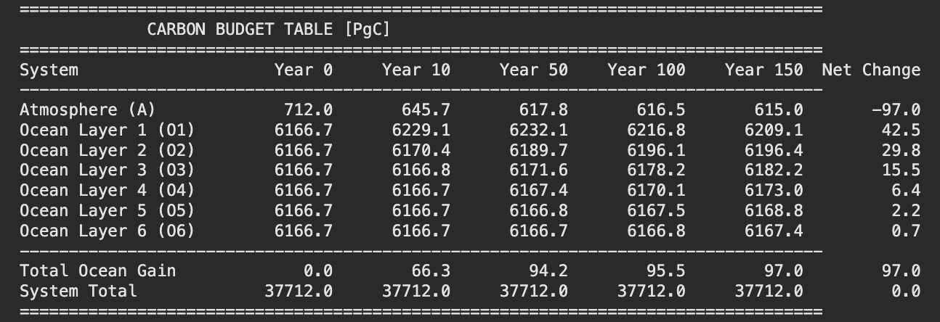
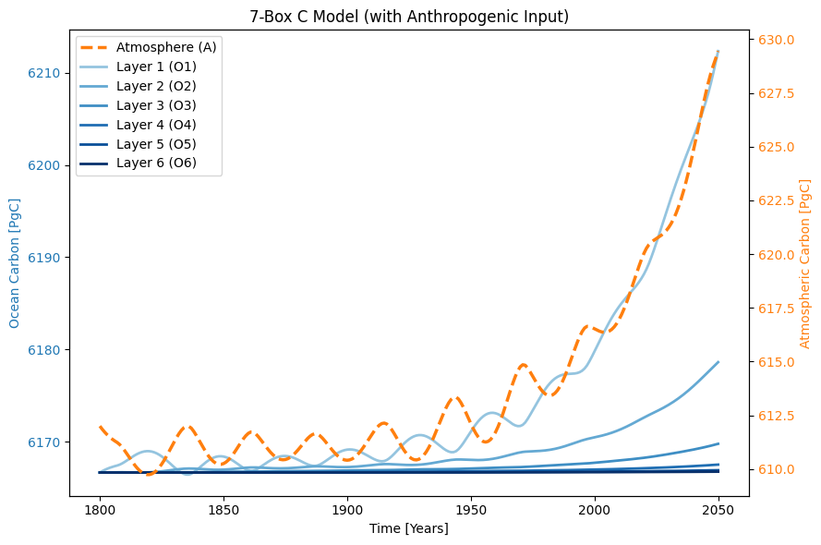
Adding the anthropogenic C into the framework will result in a non-zero net C change in the whole system and this is the result of having an increasing C in both the atmosphere and ocean layers. By changing the atmosphere ODE and adding the increasing anthropogenic C over time, here is the result of 250yrs C transfer thru various ocean layers. It is seen that there is a roughly similar pattern to the previous model that top 3 layers of the ocean will store most of the C and only a very small percentage of C will be stored in the next 3 deeper ocean layers. It is also important to note that the Atmospheric C is constantly increasing and the net C in the system will increase accordingly.

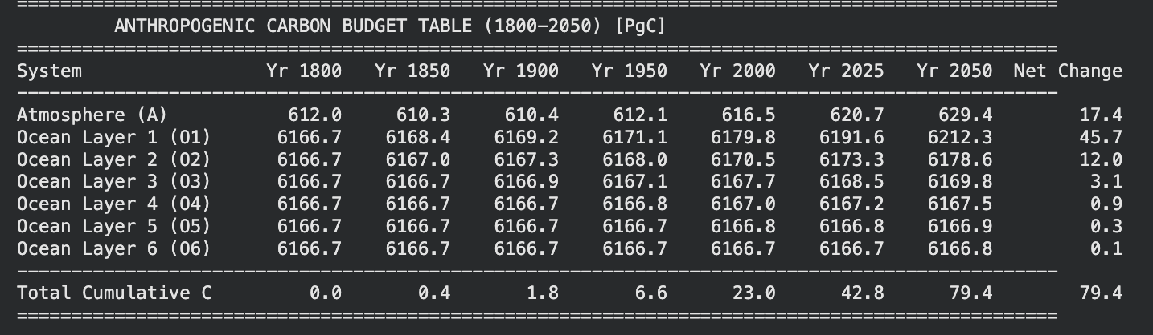
Q.2)
Here is the very simple tanh function plot for the -10 to +10 range of X values:
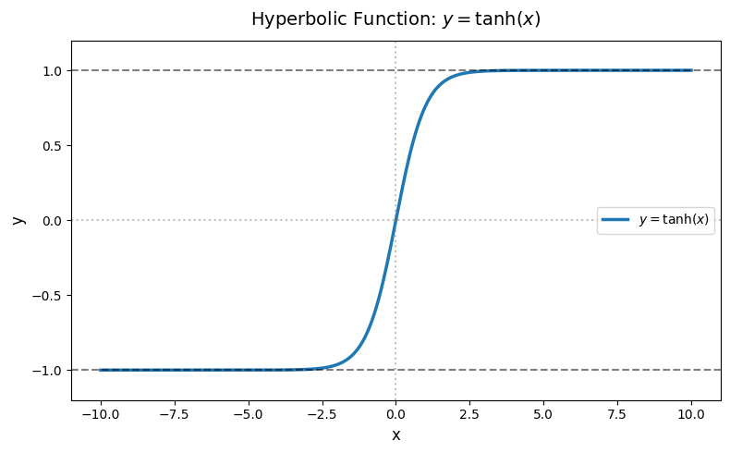
Incorporating the tanh function into the planet modeling to get the true values of albedo by increasing temperature. I also used the 0.7 and 0.1 as the max and min values for the planet albedo’s threshold.
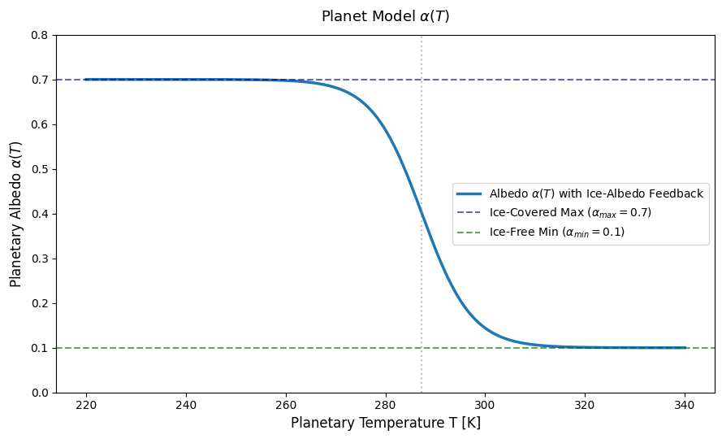
I have defined the T_warm = T_current + 5.0 and then calculated the 𝛼₊ = 0.25 by using the equation 1. So, the overall function will look like the below new curve with center of 0.275:
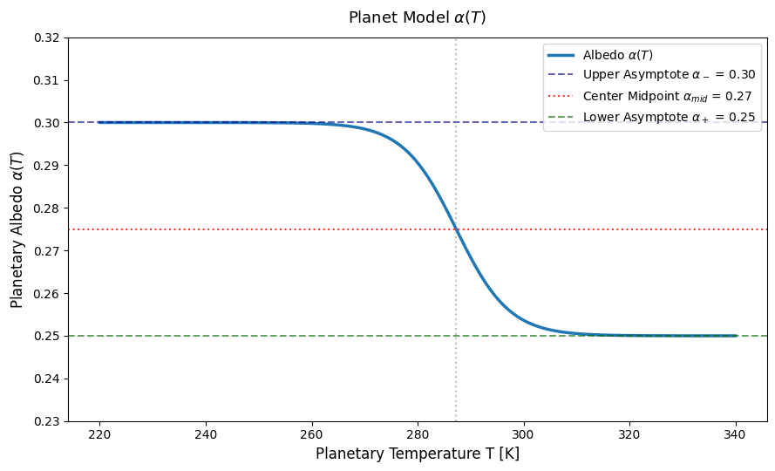

By having the T=298.3 K and put the requested changes the updated curve will be here:
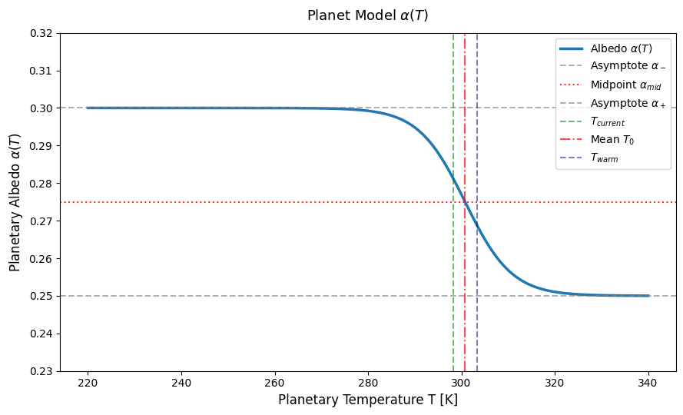
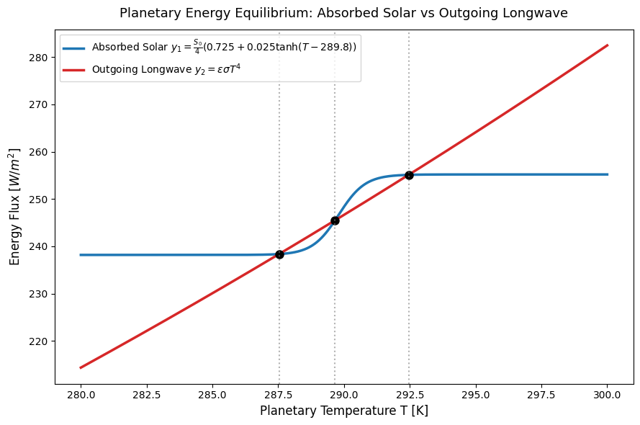
For the next step to find out the equilibrium temperature, I used the scipy.optimize to find out equilibrium temperature and found the points as shown here:

Finally, I used the [Energy in – Energy out] concept to get the net energy flux for stability analysis. Here are the details of points and stability anlysis:
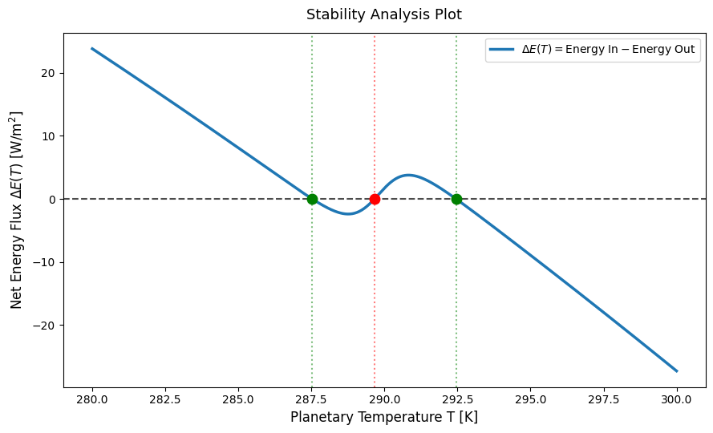

Equilibrium T1 = 287.5 K, (Delta E) = -2.95 W/(m^2 K), Status: Stable
Equilibrium T2 = 289.6 K, (Delta E) = 4.94 W/(m^2 K), Status: Unstable
Equilibrium T3 = 292.4 K, (Delta E) = -3.32 W/(m^2 K), | Status: Stable

When epsilon decreases, the greenhouse effect will increase, and it means to have more trapped longwaves radiation. So, I think the planet will need a higher temperature to emit enough radiation to balance incoming solar energy (Delta E). In this case, the net energy flux curve shifts higher and that will push the stable equilibrium Temperature to the right (warmer T values).

